Baltimore County Public Library

- Log into the computer.

- Go to www.bcpl.info

- Click on Find Info.

- Select Databases by Subject.

- Scroll down to the Homework section. Click on AskUsNow. You do not need a library card for this service.
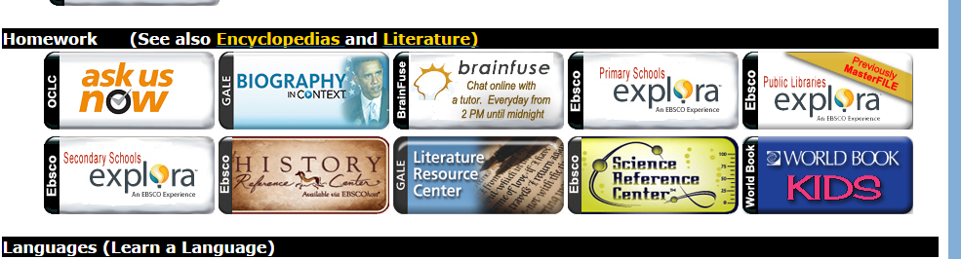

- X out of Ask Us Now log-in tab.

- In the Homework section, click on Brainfuse. Log in with your Student Account. The password is “0000”.

There may be some services within Brainfuse in which you need to create an account with your personal email address and a password of your choice. You must do this at home, not at school.

If you want tutoring through Brainfuse, you do not need a separate account.

If you are at a Baltimore County Public Library branch, you do not need to type in your Student Account information.

- X out of the Brainfuse tab.

- On the database page, Find the Literature section, click NoveList Plus. Click on Teen. Find a book that you might like to check out. You can ask Ms. Magnuson or Mrs. Hall if we have the book.

The book I might like is _________________________________ by

______________________________________________.

- Go back to the Database by Subject tab, in the Do It Yourself section, click on Hobbies and Crafts Reference Center. Click on View All Topics. Click on a topic that interests you. Click on a link that interests you.

The topic I chose is ______________________________________________.

Click on one of the titles that looks interesting to you. You may need to click on PDF full text on the left tool bar.

The link I clicked on is ____________________________________________.

One new thing I learned is

_______________________________________________________________.

When you are finished, give this paper to your EH teacher. Make sure your name is on the paper.

