Citing a Database Source in NoodleTools

Choose your database article. Copy the MLA citation at the bottom of the article.

In your NoodleTools Project:

Click on Create New Citation

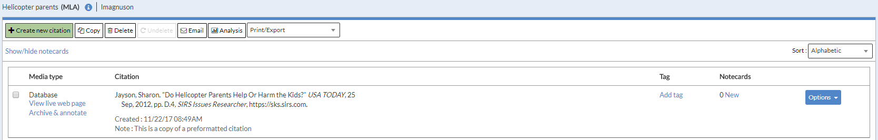

Click on Database

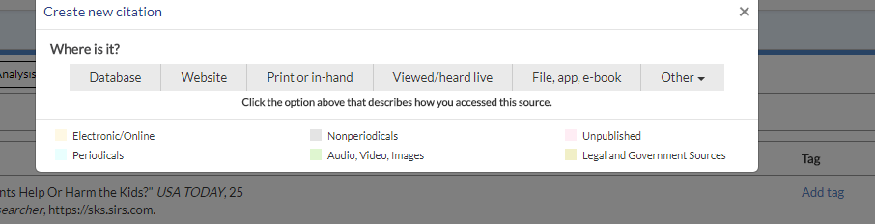

Click on Quick Cite: Copy and Paste Citation

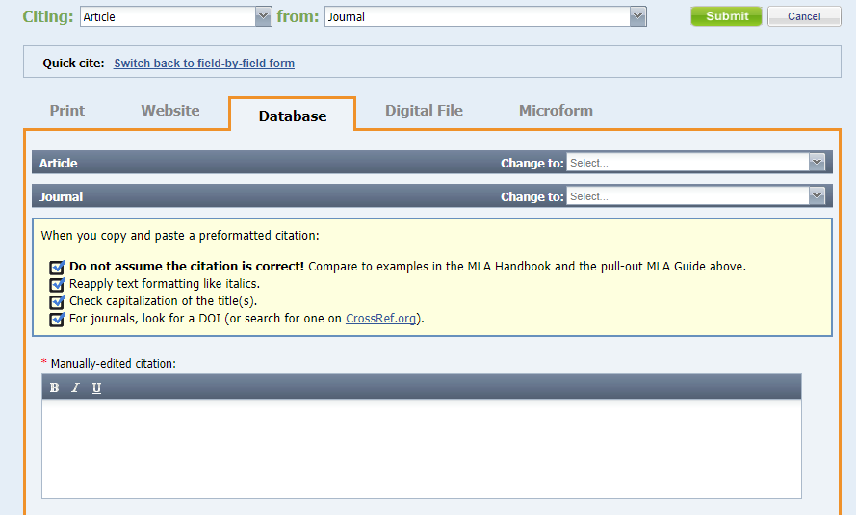
Paste the citation in the box. It is your job to make sure it is correct.
Click the green Submit button at the bottom of the page.

