Creating a Kenwood NoodleTools Account

Go to our customized log in page. (This link will be on the Kenwood Library Wiki and on your teacher’s BCPSOne calendar.) You CANNOT get to your account through the general NoodleTools website.

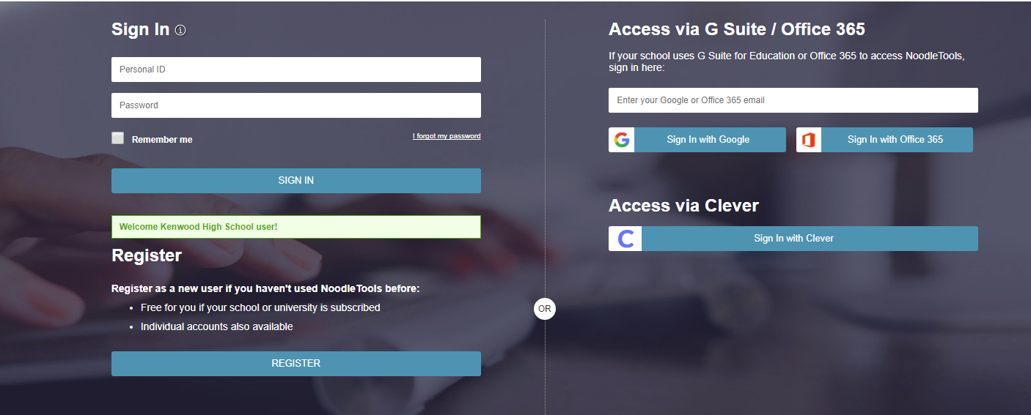
Click on Register

See Ms. Magnuson or your teacher for the password.
Keep the same

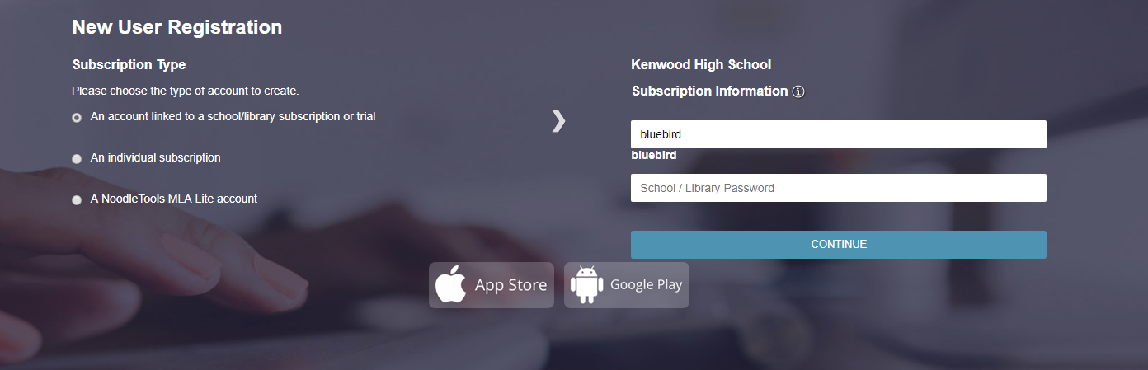
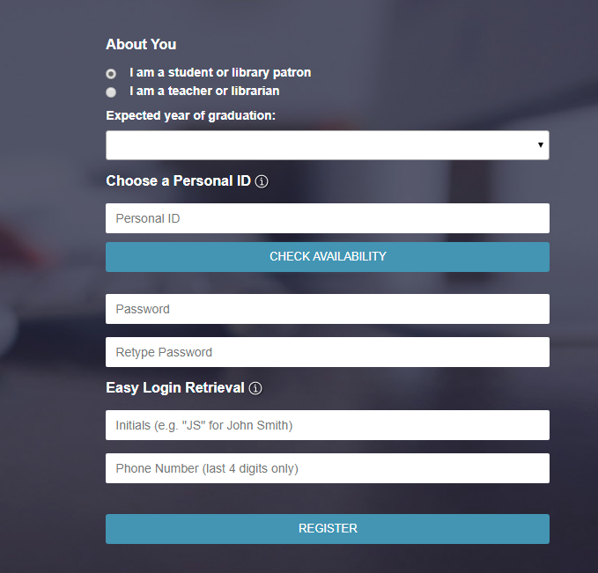
Password: make up your own
Personal ID—Your BCPS Username

Do this so if you forget your password, you can get a hint. If you don’t have a phone, use 0000. If you still can’t remember, Ms. Magnuson can reset your password.

