How to Access The OverDrive Database To Check Out E-Books

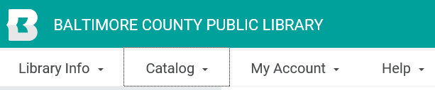
- Once you have logged into your BCPL account, click on “Catalog” at the top of the screen.

- Click on “Research Databases” from the dropdown menu.
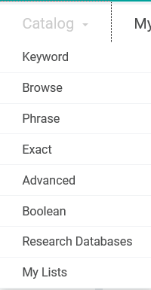

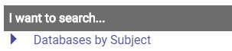
- Click on I want to search….”Databases by Subject”

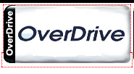
- Click on the “OverDrive” database app button.

- Click on the “Teens” tab at the top of the screen. (Students can also select the “Kids” tab).
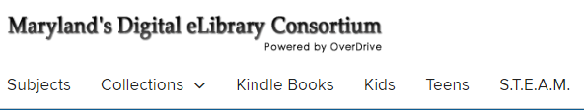

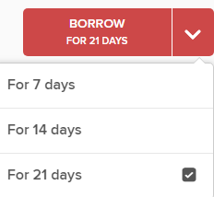
- Select a book that you would like to check out and click on the red arrow next to where it says “Borrow”. Change the checkout period to 21 days.

How To Access E-Books You Have Checked Out and Begin Reading Them
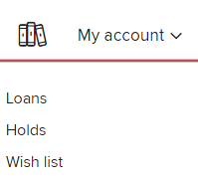
- While in OverDrive, click on “My Account” in the upper right hand corner and select “Loans”.

- Find the E-book you want to begin reading and click “Read now in browser”.
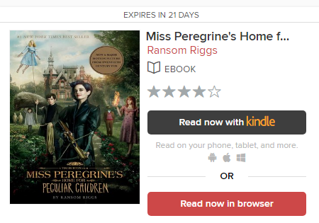

- If you finish a book or decide you no longer want to continue reading it, you can remove it from your account at any time by clicking on the “Return” button at the bottom of the book.
