How to create notecards

1. Click Notecards in the navigation bar at top.
2. On the Notecard Tabletop, click New.
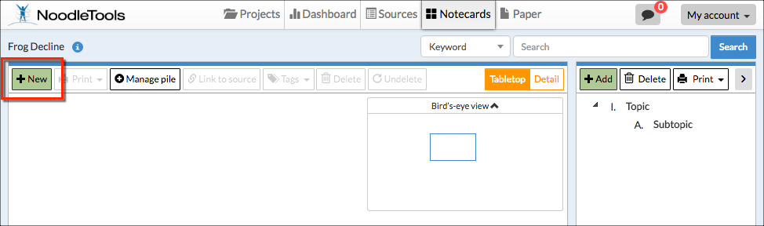

3. Input notes about your source.

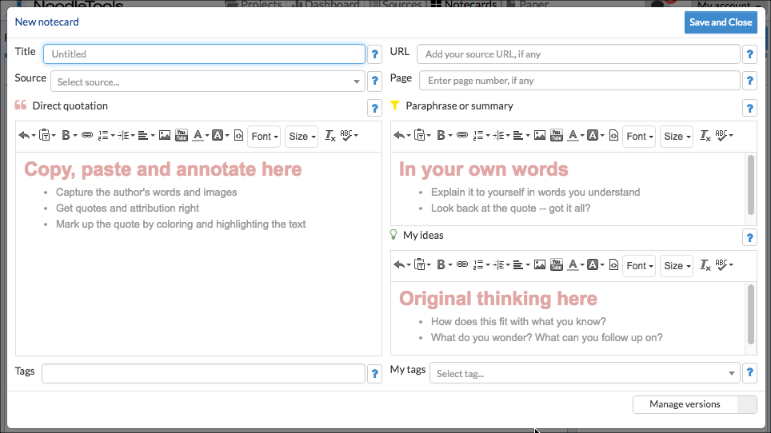
4. Your notecard gets saved automatically as you add information. When you are done, click Save and Close to save your final changes and close the window. New notecards appear in the upper left corner of your tabletop and in the bird's eye view.

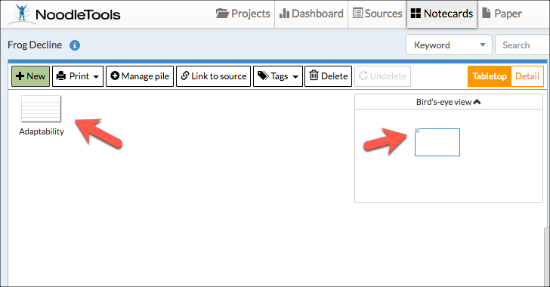

TIP: Once you've created multiple notecards, you can pile them. Drag a notecard and drop it on another notecard to create a new pile, or use the Manage pile option above the tabletop to manage existing and create new piles with selected notecards. Notecard piles become the basis of organization within the Outline panel next to the Notecard Tabletop.

