How to share a project with your teacher
1. On your project's Dashboard screen, under Sharing, click Share with a project inbox.

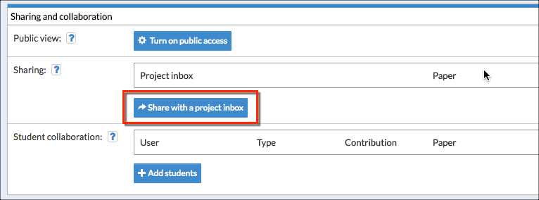

2. In the Project inbox field, enter the name of the inbox (as provided by your teacher). When the first letter of the inbox’s name is entered, a drop-down menu will appear and the name of the drop box can be selected
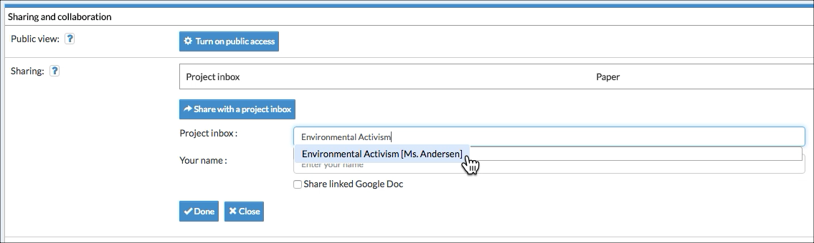

3. Enter your name so that your teacher can identify you (if not clear from your username).

4. If you already linked a Google Doc to your project via Paper in the top navigation, you can check Share linked Google Doc.

5. Click Done.

6. On the Dashboard screen you will now see the inbox’s name under Project inbox.

7. On the Projects screen, you will see a checkmark in the Shared? column.

