How to start a new project

1. On the Projects screen, click New project.

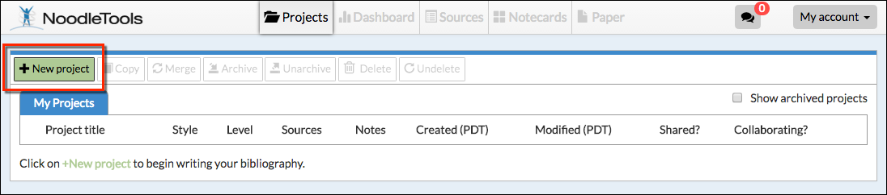

2. On the Create a New Project screen that pops up, enter a name for your project. 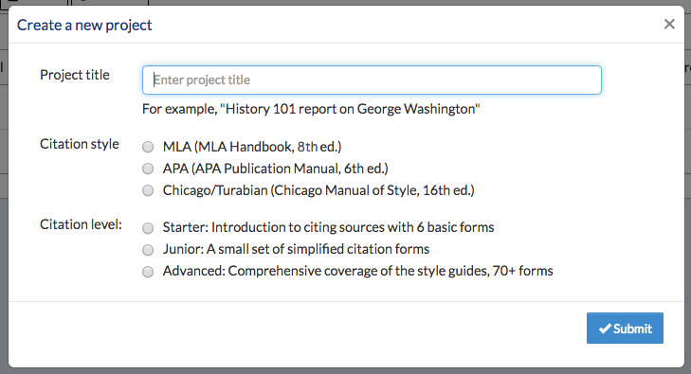
Click Submit
Citation Level: Choose Advanced
Citation Style: Choose MLA

3. The Dashboard screen appears. The Dashboard organizes your work environment for effective research. You can see assignments, create to-do lists, submit work, and act on feedback from teachers in an organized way, and all in one place.
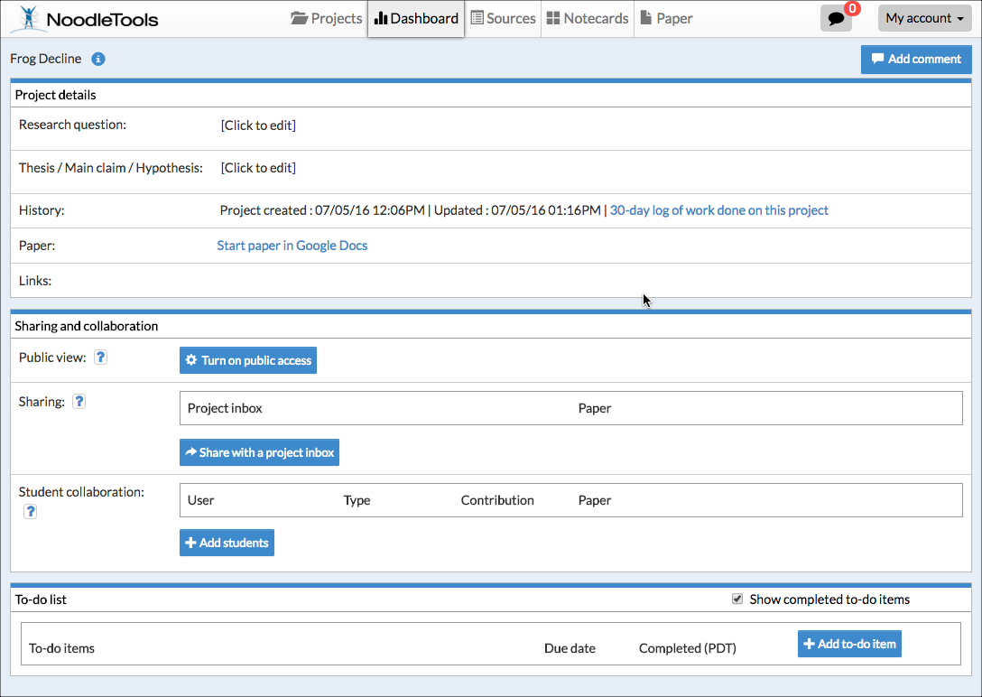
You can share with your teacher
You can share with your partner(s)

