How to start a source list

4. To begin citing sources, click Sources in the navigation bar at the top.

5. On the Sources screen, click Create new citation and select the best match for your source from the choices given.
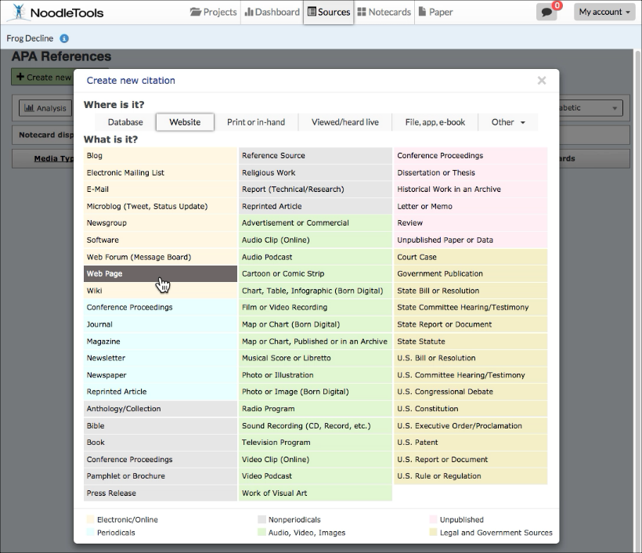
6. On the next screen, depending on the citation type selected, a Show Me tutorial may be available to help you evaluate the source. The lessons are differentiated based on which level you are in: Starter, Junior, or Advanced. Below is an example of a slide from the Show Me tutorial for Website, Junior level.

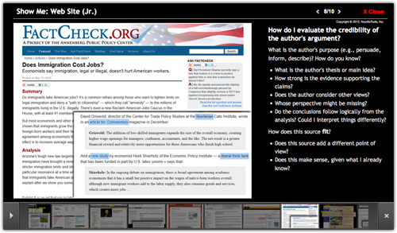

7. Click Continue to go to the next screen.
8. Fill in the citation form with information about your source. If your source is a book, you can locate the book in WorldCat (via an ISBN number or title/author search) and it will automatically fill in the form with the book's details, checked and revised for accuracy by NoodleTools.

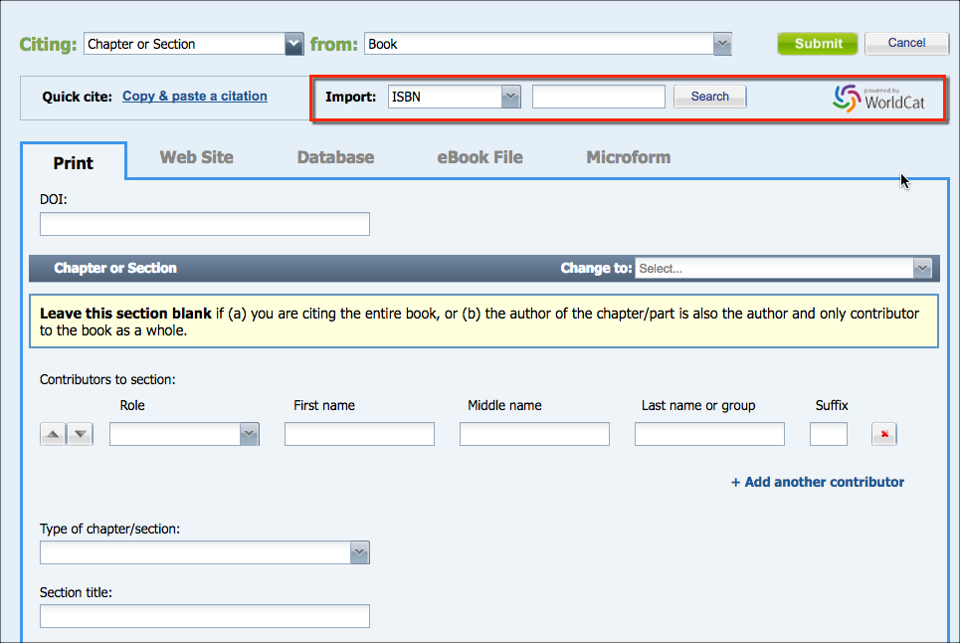

9. After you finish entering information about your source, click Submit to save your new citation.

