How to set up a project inbox to receive student work and provide feedback

An inbox is where students submit a specific project for your review so that you can monitor progress and provide feedback on their work.

1. Click the Inboxes tab and New project inbox.

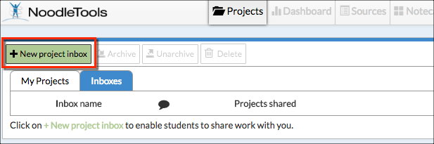

2. In the New project inbox screen enter a name for your inbox. In the Additional recipients’ field, teachers' IDs can be added to allow them to view and provide feedback on projects submitted to this inbox. Click Submit.
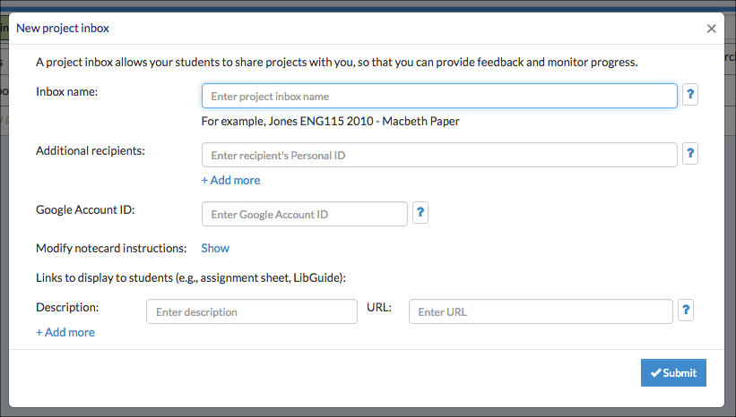

3. The new inbox now appears under Inboxes on your Projects screen.
4. Share the name of the new inbox with your students.
For more details on setting up your inbox, please see "How to set up an inbox and work with projects shared with you."

See "How to share your project with a teacher" to understand the process by which students submit their projects to the inbox.

